Logging into Your Google Account
1. Open Google Chrome 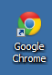
- If you don’t see a shortcut for the program on your desktop, open the Programs folder on your desktop.
- If it’s not in the Programs folder, then click Start; Programs and find it in the list.
- If you STILL don’t see it, call the Help Desk at ext. 6180.

2. In the Address field, key in google.com
3. At the top, right corner, click the Sign in button. It looks like this: 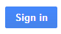
4. Sign in to your Google account.
- You do not need to create an account! You already have one.
- If this is the first time that you have logged into your District 158 Google Account, your password is the word, students.
- Your user name is your District 158 email address. (for instance, jdoe@district158.org)
- Click the little box next to “Stay signed in”
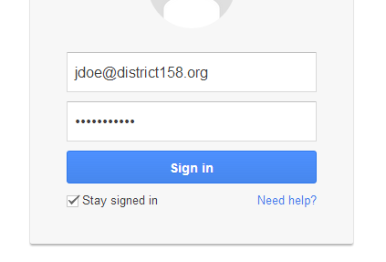
- If this combination doesn’t work, call the Technology Department at ext. 6180 to have your Google password reset.

5. You will be notified that your initial password has expired, and a change password screen will appear.
- Reset your Google password to a word/number combination that is at least 8 characters long.
- As you key in the new password, Google will tell you if the password that you are selecting is “weak” or “strong.” Use a password that it thinks is “strong.”
- Next time you log into your Google account, use your new password.

6. When you are successfully logged into your Google account, you’ll see your email address at the top, right corner of the screen. You will also see a square that consists of nine small squares. It looks like this:
- Click the square.
- To see documents that have been shared with you, click on Drive.

