Using Google Drive -- Creating and Sharing with Others

To create a file that you will share with others:
- Log into your Google account, using Google Chrome.
- Click the icon. Then click
- At the left side of the screen, click the icon. icon.

- Select the type of file that you would like to create:

Select : | Similar to Microsoft:
Document | Word
Presentation | PowerPoint
Spreadsheet | Excel

The selections above work similarly to the Microsoft versions, though they aren’t quite as robust.
You can also select Form and Drawing for specialized files.
- When you are finished with your file, click the icon. Then give your file a name.

- If you don’t want to share this with anyone, just click Done. The file will be saved in your My Drive section of Google Drive.

- If you do want to share it with one or more people, enter the email address(es) of those to whom you’d like to share. Note: Recipients must have a Google account in order to open the file.

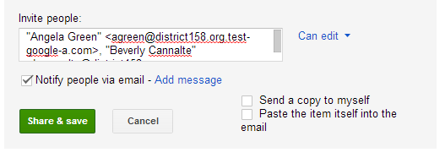

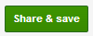
- Once you click the green, link, the recipients will receive a notification in their Outlook email account that you are sharing a file with them. By default, they will be able to edit the file.

- If you do not want the recipients to be able to change the file (just view it), click the Can edit link and select Can Comment or Can View before clicking

Other Options:
- If you do not want to notify people via email that you are sharing a file with them, un-check the box next to “ Notify people via email”. You might do this if the recipient has previously told you that there is no need to include the notification email.

- If you do want to notify people, keep the box checked. You can also click the Add message link and add a comment to be sent in the email. For instance:
“Chris, I’m sharing this document with you. Can you please fix any errors that you see before I send it out? Thanks.”

- The people with whom you share the file can add other people to the sharing list and change their viewing permissions. If you don’t want your recipient to be able to do this, click the Change link at the bottom of the Shared settings page.
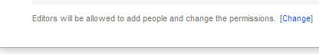
Then click the radio button next to “Only the owner can change the permissions.”

