Using Google Drive -- Opening Files that Have Been Shared with You
After logging into Google, click the icon at the top, right of the screen. You’ll see many functions of Google that are open for you to use. This section will concentrate on using Google Drive.
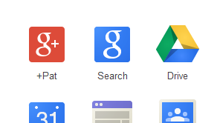

“Google Drive” is the new term for “Google Docs.” It’s being used in the district to share files with other people, or to view files that have been shared with you. These files can be Word, Excel, PowerPoint, etc. files, OR files that are created within Google Drive.

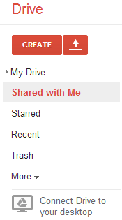
“Shared with Me” – is where you’ll find files that others have shared with you.
“My Drive” …is a place where you can store your files. It’s similar to your H: drive, but in the cloud.

You will know that a file is being shared with you in one of two ways:
- If you are in Google Drive, you’ll see it listed in the Shared with Me area:
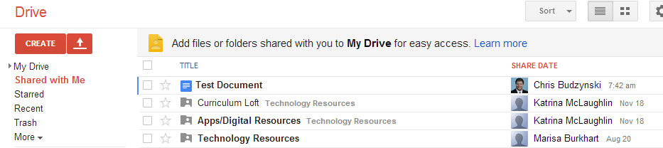

- When other teachers/staff share a document with you, they normally also include a notification email to your Outlook account. It will look something like this:
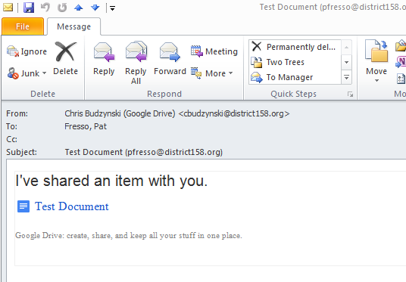

If you receive this kind of notification:
- Log into your Google account, using Google Chrome.
- Select Drive
- Open the file from the “ Shared with Me” section.

